For B. Sc.III Year (Organic Chemistry)
Nuclear Magnetic Resonance Spectroscopy
By: Dr. Rakesh Mani Mishra
Assistant Professor Department of Chemistry
Harishchandra post Graduate College Varanasi

Nuclear magnetic resonance involves the interaction between an oscillating magnetic field of electromagnetic radiation and the magnetic energy of the hydrogen nucleus or some other type of nuclei when these are placed in an external static magnetic field. The sample absorbs electromagnetic radiation in radio wave region at different frequencies since absorption depends upon the type of protons or certain nuclei contained in the sample. For example we may consider a spinning top. It also perform a slower waltz like motion in which the spinning axis of top moves slowly around the vertical this is processional motion. The precession arises from the interaction of spin with earth,s gravity acting vertically downward it is called gyroscopic motion.
When placed in a magnetic field, charged particles will precess about the magnetic field. In NMR, the charged nucleus, will then exhibit precessional motion at a characterisitc frequency known as the Larmor Frequency. The Larmor fequency is specific to each nucleus. The Larmor fequency is measured during the NMR experiment, as it is dependent on the magnetic field that the nucleus experineces.

Spinning Top Analogy
Often it is difficult in NMR to understand the microscopic processes that are occurring. However, precession is easily observed on the macroscopic scale, as toy tops. When a top is spun, it rotates about a central axis (Figure 1). The angular momentum of the top (L) is aligned along this central axis. If the top is set at an angle, the central axis will move in a circle. The top now spinning along its own central axis precesses around in a circle around earths gravitational field.
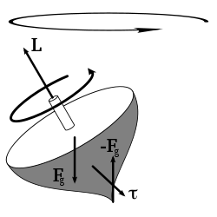Figure 1: This diagram explains the precession of a top. The torque created by the force of gravity applied at the center of gravity and the reactive force applied where the top touches the table causes the top to preces.
Atomic nuclei contain intrinsic spin. The nucleus, like a top, will spin along an axis, which is the direction of the angular momentum for the nucleus. The spin of the nucleus can be related to the magnetic moment of the nucleus through the relation
μ=γI(1)(1)μ=γI
where
- μ is the magnetic moment and
- γ is a proportionality constant known as the gyromagnetic moment.
This constant may be positive or negative, depending on if the nucelus precesses clockwise or counterclockwise, respectively. The nuclear magnetic moment will couple to the external magnetic field, which produces a torque on the nucleus and causes the precession around the magnetic field. This is analgous to the macroscopic tops in that the gravitational force couples with the mass of the top. In the absence of friction, the top would precess forever! The frequency of precession is known as the Larmor frequency, ν₀ where
ν₀=γB₀(2)ν₀=γB₀
The effect is illustrated below:

Precessional Frequency
“The precessional frequency may be defined as the number of revolutions per second made by the magnetic moment vector of the nucleus around the external field H_{0.}Alternatively the precessional frequency of the spinning bar magnet may be defined as equal to the frequency of electromagnetic radiation in megacycle necessary to induce a transition from one spin state to another.
- Properties of Spin Spin is a fundamental property of nature
- Any unpaired electron, proton, or neutron will possess a spin of ½
- Atomic nuclei, which are composed of protons and neutrons, may also possess spin The spin of an atomic nucleus is determined by the number of protons and neutrons
- Atoms with odd number of protons will have spin
- Atoms with odd number of neutrons will have spin
- Atoms with EVEN number of protons and neutrons will not have spin The value of the nuclear spin is defined by I, the nuclear spin quantum number and can have values of (I = 0, 1/2, 1, 3/2, 2, 5/2, …) A nucleus of spin I can exist in (2I+1) spin states. We will primarily deal with spin ½ nuclei “Spin is a highly abstract concept, which may never be entirely ‘grasped’ beyond knowing how to manipulate the quantum mechanical equations.” -Spin Dynamics. Basics of Nuclear Magnetic Resonance. (2002) Levitt Magnetic properties of atomic nuclei
- The nuclear spin quantum number (I) will have a corresponding angular momentum (L) and a set of quantized spin states. • The magnitude of the spin angular momentum is give by: 1)+ I(I η =L I∝L Magnetic properties of atomic nuclei
- The moment of the spin angular moment is quantized i.e. only those nuclei will have a finite value of spin quantum number (I>0) will precess along the axis of rotation.
- Simply it may be expressed as
ω = ɣH₀
where ω = angular precessional velocity
_{H0 = applied field in guass}
_{ɣ = Gyromagnetic ratio = 2π}µ/ hI
here µ= magnetic moment of the spinning bar magnet
I = Spin quantum number of the spinning magnet
h = plancks constant
According to the fundamental NMR equation which correlates electromagnetic frequencies with magnetic field we say that
ɣH_{0 =2πv}
Here v is frequency of electromagnetic radiation

Mass number | Atomic number | Spin quantum number I
odd | Odd or even | ½, 3/2, 5/2……
even | even | 0
even | odd | 1,2,3………..
Proton NMR Spectroscopy
This important and well-established application of nuclear magnetic resonance will serve to illustrate some of the novel aspects of this method. To begin with, the nmr spectrometer must be tuned to a specific nucleus, in this case the proton. The actual procedure for obtaining the spectrum varies, but the simplest is referred to as the continuous wave (CW) method. A typical CW-spectrometer is shown in the following diagram. A solution of the sample in a uniform 5 mm glass tube is oriented between the poles of a powerful magnet, and is spun to average any magnetic field variations, as well as tube imperfections. Radio frequency radiation of appropriate energy is broadcast into the sample from an antenna coil (colored red). A receiver coil surrounds the sample tube, and emission of absorbed rf energy is monitored by dedicated electronic devices and a computer. An nmr spectrum is acquired by varying or sweeping the magnetic field over a small range while observing the rf signal from the sample. An equally effective technique is to vary the frequency of the rf radiation while holding the external field constant.
For a description of the pulse Fourier transform technique, preferred by most spectroscopists over the older CW method
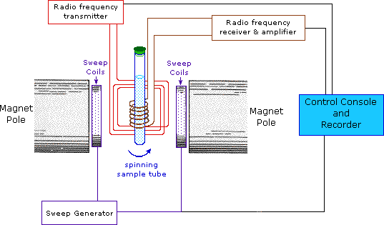
As an example, consider a sample of water in a 2.3487 T external magnetic field, irradiated by 100 MHz radiation. If the magnetic field is smoothly increased to 2.3488 T, the hydrogen nuclei of the water molecules will at some point absorb energy and a resonance signal will appear

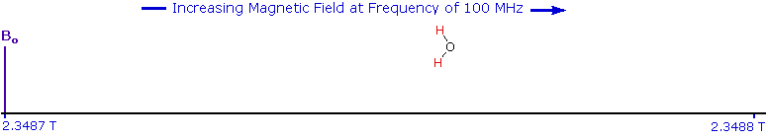

Since protons all have the same magnetic moment, we might expect all hydrogen atoms to give resonance signals at the same field / frequency values. Fortunately for chemistry applications, this is not true. By clicking the Show Different Protons button under the diagram, a number of representative proton signals will be displayed over the same magnetic field range. It is not possible, of course, to examine isolated protons in the spectrometer described above; but from independent measurement and calculation it has been determined that a naked proton would resonate at a lower field strength than the nuclei of covalently bonded hydrogens. With the exception of water, chloroform and sulfuric acid, which are examined as liquids, all the other compounds are measured as gases.

Flipping of Proton:

The magnetic moment of the nucleus forces the nucleus to behave as a tiny bar magnet. In the absence of an external magnetic field, each magnet is randomly oriented. During the NMR experiment the sample is placed in an external magnetic field, B₀, which forces the bar magnets to align with (low energy) or against (high energy) the B₀. During the NMR experiment, a spin flip of the magnets occurs, requiring an exact quanta of energy. To understand this rather abstract concept it is useful to consider the NMR experiment using the nuclear energy levels.

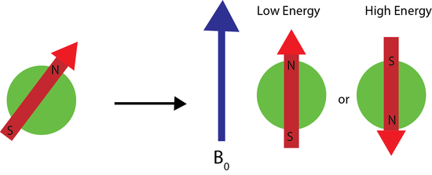
Figure NMR.2: Application of a magnetic field to a randomly oriented bar magnet. The red arrow denotes magnetic moment of the nucleus. The application of the external magnetic field aligns the nuclear magnetic moments with or against the field.

Nuclear Energy Levels
As mentioned above, an exact quanta of energy must be used to induce the spin flip or transition. For any m, there are 2m+1 energy levels. For a spin 1/2 nucleus, there are only two energy levels, the low energy level occupied by the spins which aligned with B₀ and the high energy level occupied by spins aligned against B₀. Each energy level is given by
E=−mℏγB₀(NMR.2)E=−mℏγB₀
where m is the magnetic quantum number, in this case +/- 1/2. The energy levels for m>1/2m>1/2, known as quadrupolar nuclei, are more complex and information regarding them can be found here.
The enerssgy difference between the energy levels is then
ΔE=ℏγB₀(NMR.3)ΔE=ℏγB0
where ℏ is Planks constant.
A schematic showing how the energy levels are arranged for a spin=1/2 nucleus is shown below. Note how the strength of the magnetic field plays a large role in the energy level difference. In the absence of an applied field the nuclear energy levels are degenerate. The splitting of the degenerate energy level due to the presence of a magnetic field in known as Zeeman Splitting.
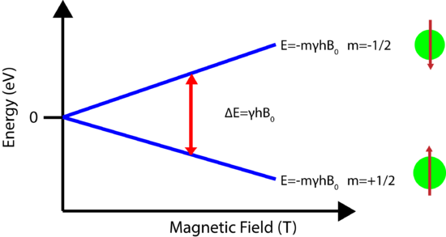
Figure 3: The splitting of the degenerate nuclear energy levels under an applied magnetic field. The green spheres represent atomic nuclei which are either aligned with (low energy) or against (high energy) the magnetic field.

Energy Transitions (Spin Flip)
In order for the NMR experiment to work, a spin flip between the energy levels must occur. The energy difference between the two states corresponds to the energy of the electromagnetic radiation that causes the nuclei to change their energy levels. For most NMR spectrometers, B₀ is on the order of Tesla (T) while γ is on the order of 107. Consequently, the electromagnetic radiation required is on the order of 100's of MHz and even GHz. The energy of a photon is represented by
E=hν(NMR.)E=hν
and thus the frequency necessary for absorption to occur is represented as:
ν=γB₀2π(NMR.)ν=γB02π
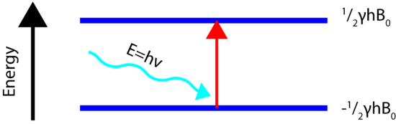Figure 4: Absorption of radio frequency radiation to promote a transition between nuclear energy levels, called a spin flip.

Relaxation processes
How do nuclei in the higher energy state return to the lower state? Emission of radiation is insignificant because the probability of re-emission of photons varies with the cube of the frequency. At radio frequencies, re-emission is negligible. We must focus on non-radiative relaxation processes (thermodynamics!).
Ideally, the NMR spectroscopist would like relaxation rates to be fast - but not too fast. If the relaxation rate is fast, then saturation is reduced. If the relaxation rate is too fast, line-broadening in the resultant NMR spectrum is observed.
There are two major relaxation processes;
- Spin - lattice (longitudinal) relaxation
- Spin - spin (transverse) relaxation
Spin - lattice relaxation
Nuclei in an NMR experiment are in a sample. The sample in which the nuclei are held is called the lattice. Nuclei in the lattice are in vibrational and rotational motion, which creates a complex magnetic field. The magnetic field caused by motion of nuclei within the lattice is called the lattice field. This lattice field has many components. Some of these components will be equal in frequency and phase to the Larmor frequency of the nuclei of interest. These components of the lattice field can interact with nuclei in the higher energy state, and cause them to lose energy (returning to the lower state). The energy that a nucleus loses increases the amount of vibration and rotation within the lattice (resulting in a tiny rise in the temperature of the sample).
The relaxation time, T₁ (the average lifetime of nuclei in the higher energy state) is dependant on the gyromagnetic ratio of the nucleus and the mobility of the lattice. As mobility increases, the vibrational and rotational frequencies increase, making it more likely for a component of the lattice field to be able to interact with excited nuclei. However, at extremely high mobilities, the probability of a component of the lattice field being able to interact with excited nuclei decreases.
Spin - spin relaxation
Spin - spin relaxation describes the interaction between neighbouring nuclei with identical precessional frequencies but differing magnetic quantum states. In this situation, the nuclei can exchange quantum states; a nucleus in the lower energy level will be excited, while the excited nucleus relaxes to the lower energy state. There is no net change in the populations of the energy states, but the average lifetime of a nucleus in the excited state will decrease. This can result in line-broadening.
Number of Signals in NMR Spectra:
The number of signals in NMR spectrum tells the number of different sets of equivalent protons in a molecule. Each signal corresponds to a set of equivalent protons. “ It may be noted that magnetically equivalent protons are chemically equivalent protons”.
In an external magnetic field of a given strength, protons in different locations in a molecule have different resonance frequencies, because they are in non-identical electronic environments. In methyl acetate, for example, there are two ‘sets’ of protons. The three protons labeled H_{a} have a different - and easily distinguishable – resonance frequency than the three H_{b} protons, because the two sets of protons are in non-identical environments: they are, in other words, chemically nonequivalent.
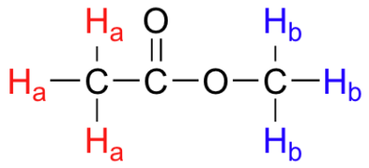
On the other hand, the three H_{a} protons are all in the same electronic environment, and are chemically equivalent to one another. They have identical resonance frequencies. The same can be said for the three H_{b} protons.
The ability to recognize chemical equivalancy and nonequivalency among atoms in a molecule will be central to understanding NMR. In each of the molecules below, all protons are chemically equivalent, and therefore will have the same resonance frequency in an NMR experiment.
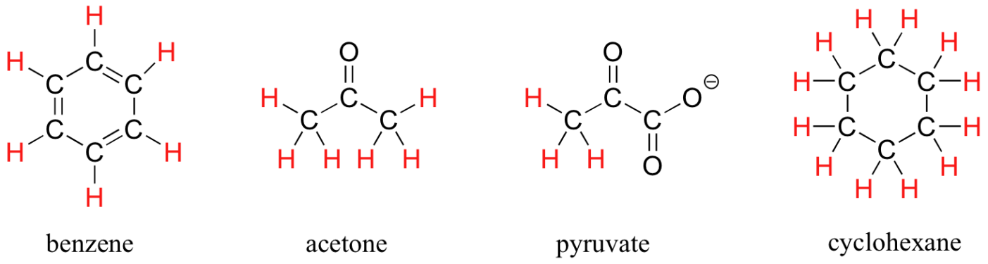
You might expect that the equitorial and axial hydrogens in cyclohexane would be non-equivalent, and would have different resonance frequencies. In fact, an axial hydrogen is in a different electronic environment than an equitorial hydrogen. Remember, though, that the molecule rotates rapidly between its two chair conformations, meaning that any given hydrogen is rapidly moving back and forth between equitorial and axial positions. It turns out that, except at extremely low temperatures, this rotational motion occurs on a time scale that is much faster than the time scale of an NMR experiment.
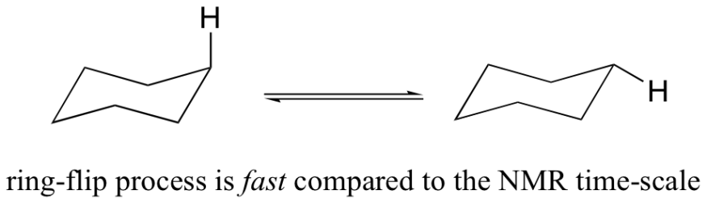
In this sense, NMR is like a camera that takes photographs of a rapidly moving object with a slow shutter speed - the result is a blurred image. In NMR terms, this means that all 12 protons in cyclohexane are equivalent.
Each the molecules in the next figure contains two sets of protons, just like our previous example of methyl acetate, and again in each case the resonance frequency of the H_{a} protons will be different from that of the H_{b} protons.
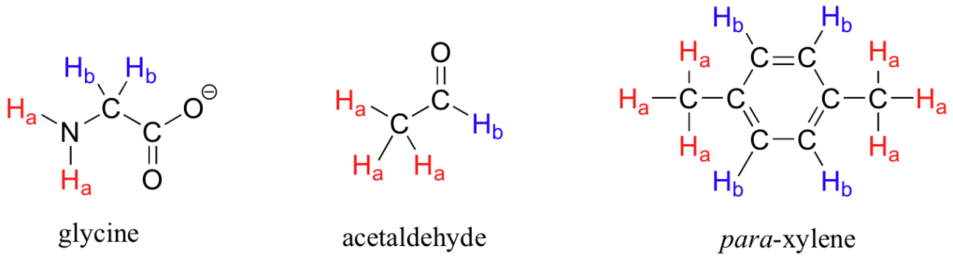
Notice how the symmetry of para-xylene results in there being only two different sets of protons.
Most organic molecules have several sets of protons in different chemical environments, and each set, in theory, will have a different resonance frequency in ¹H-NMR spectroscopy.
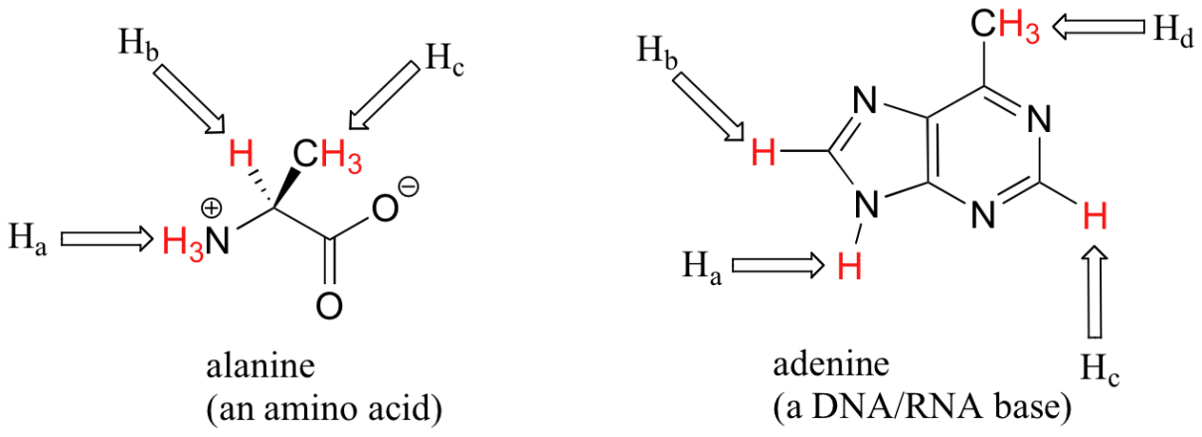
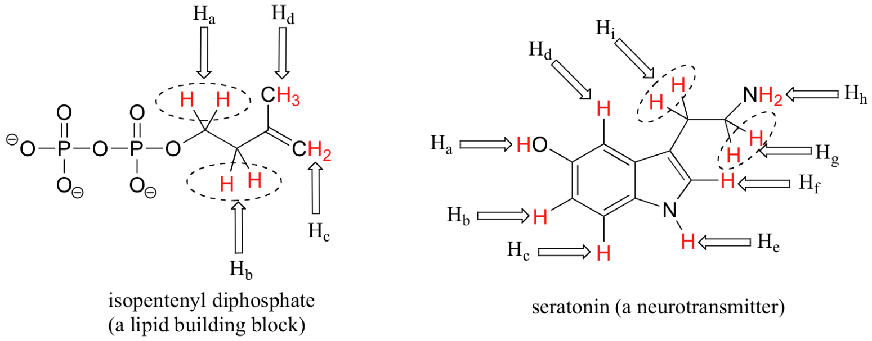
When stereochemistry is taken into account, the issue of equivalence vs nonequivalence in NMR starts to get a little more complicated. It should be fairly intuitive that hydrogens on different sides of asymmetric ring structures and double bonds are in different electronic environments, and thus are non-equivalent and have different resonance frequencies. In the alkene and cyclohexene structures below, for example, H_{a} is trans to the chlorine substituent, while H_{b} is cis to chlorine.
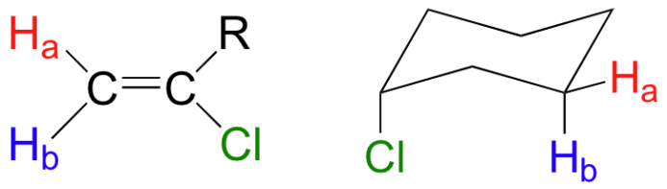
What is not so intuitive is that diastereotopic hydrogens on chiral molecules are also non-equivalent:
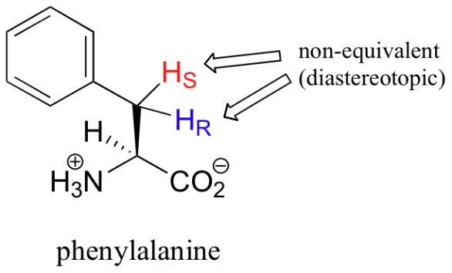
However, enantiotopic and homotopic hydrogens are chemically equivalent.
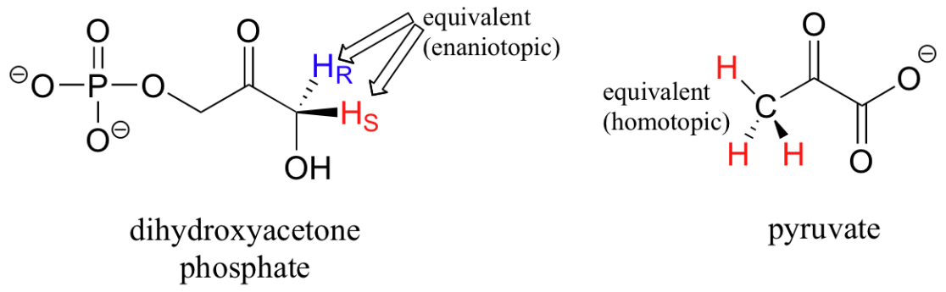
Example 1
How many different sets of protons do the following molecules contain? (count diastereotopic protons as non-equivalent).
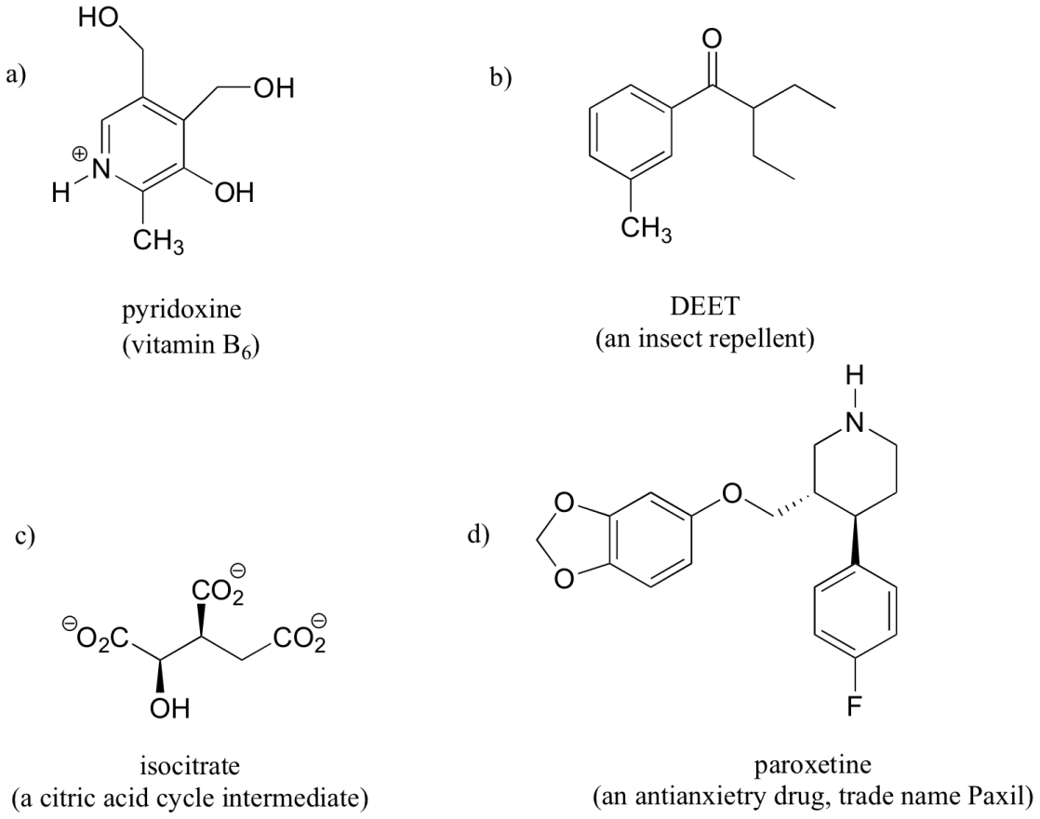

Practice

How many signals would you expect to see in the ¹H NMR spectrum of each of the following compounds?

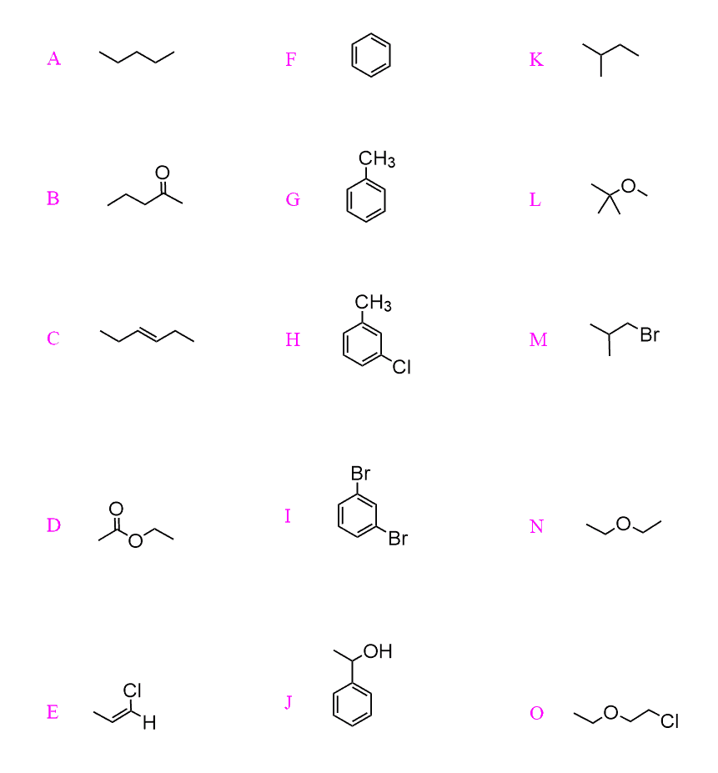

Position of Signals in NMR (Chemical Shift): Chemical shift is associated with the Larmor frequency of a nuclear spin to its chemical environment. Tetramethylsilan[TMS;(CH₃)₄Si] is generally used for standard to determine chemical shift of compounds: δ_{TMS}=0ppm. In other words, frequencies for chemicals are measured for a ¹H or ¹³C nucleus of a sample from the ¹H or ¹³C resonance of TMS. It is important to understand trend of chemical shift in terms of NMR interpretation. The proton NMR chemical shift is affect by nearness to electronegative atoms (O, N, halogen.) and unsaturated groups (C=C,C=O, aromatic). Electronegative groups move to the down field (left; increase in ppm). Unsaturated groups shift to downfield (left) when affecting nucleus is in the plane of the unsaturation, but reverse shift takes place in the regions above and below this plane. ¹H chemical shift play a role in identifying many functional groups. Figure indicates chemical shift in PMR spectra. ;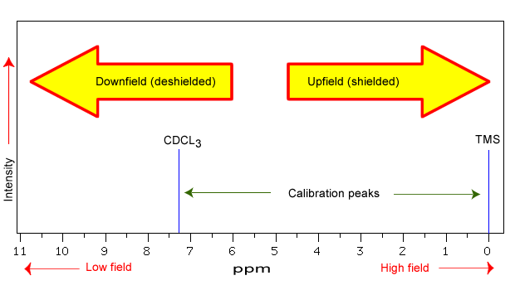

Note: greater the deshielding of proton larger will be the value of δ
In practice, chemists measure differences in NMR frequencies between a sample under investigation and an external reference standard. In 2001 the International Union of Physicists and Chemists (IUPAC) recommended abandoning the use of σ in favor of the δ-scale, with chemical shift (δ) defined as
δ = (fsamp − fref ) / fref
where fsamp is the NMR frequency of the nuclear species under investigation and fref is the NMR frequency of a reference compound.
The frequency difference (f_{samp} − f_{ref} ) is usually on the order of a few hundred to a few thousand Hz, while the reference frequency (f_{ref} ) is measured in MHz. The chemical shift (δ) is therefore a small number, expressed in units of parts per million (ppm). The suffix ppm is interchangeable with x10 ⁻⁶,
Factors Influencing Chemical Shift:

Electronegativity
Electronegative atoms present in molecules tend to draw the electron density towards themselves and deshield the nucleus. An increase in electronegativity of the surrounding groups will result in decrease of the electron density and lead to an increase in chemical shift (downfield) value.

Anisotropy
Anisotropy refers to the property of the molecule where a part of the molecule opposes the applied field and the other part reinforces the applied field. Chemical shifts are dependent on the orientation of neighbouring bonds in particular the π bonds. Examples of nucleus showing chemical shifts due to π bonds are aromatics, alkenes and alkynes. Such anisotropic shifts are useful in characterizing the presence of aromatics or other conjugated structures in molecules. In case of ethene oriented at right angles to the direction of the applied field, the induced magnetic field (due to the circulation of π electron) is diamagnetic (oppose external field) around the carbon atom and is paramagnetic in the region of proton. Thus protons feels more magnetic field.

Hydrogen bonding
Hydrogen bonding results from the presence of electronegative atoms in neighbourhood of protons .The resulting deshielding leads to higher values of chemical shifts. This confirms the presence of hydrogen bonding in the molecules.
Chemical shifts of NMR active protons and other nuclei serve to provide a wealth of structural information on molecules.

Vander Waals Deshielding
In over crowded molecule it is possible that some proton may be occupying sterically hindered position. Clearly electron cloud of a bulky group (hindering group) will tend to repel the electron cloud surrounding the proton. Thus such a proton will be deshielded and will resonate at higher value of δ than expected in the absence of this effect.

Peak Area and Proton Counting:

The concept of peak integration is that the area of a given peak in a 1H NMR spectrum is proportional to the number of (equivalent) protons giving rise to the peak. Thus, a peak which is caused by a single, unique proton has an area which measures one third of the area of a peak resulting from a methyl (CH₃) group in the same spectrum.
In practice, we do not have to measure these areas ourselves: it is all done electronically by the spectrometer, and an integration curve is superimposed on the rest of the spectrum. The integration curve appears as a series of steps, with the height of each step being proportional to the area of the corresponding absorption peak, and consequently, to the number of protons responsible for the absorption. As it can be difficult to decide precisely where to start and stop when measuring integrations, you should not expect your ratios to be exact whole numbers

The computer in an NMR instrument can be instructed to automatically integrate the area under a signal or group of signals. This is very useful, because in ¹H-NMR spectroscopy the area under a signal is proportional to the number of hydrogens to which the peak corresponds. The two signals in the methyl acetate spectrum, for example, integrate to approximately the same area, because they both correspond to a set of three equivalent protons.
Take a look next at the spectrum of para-xylene (IUPAC name 1,4-dimethylbenzene):
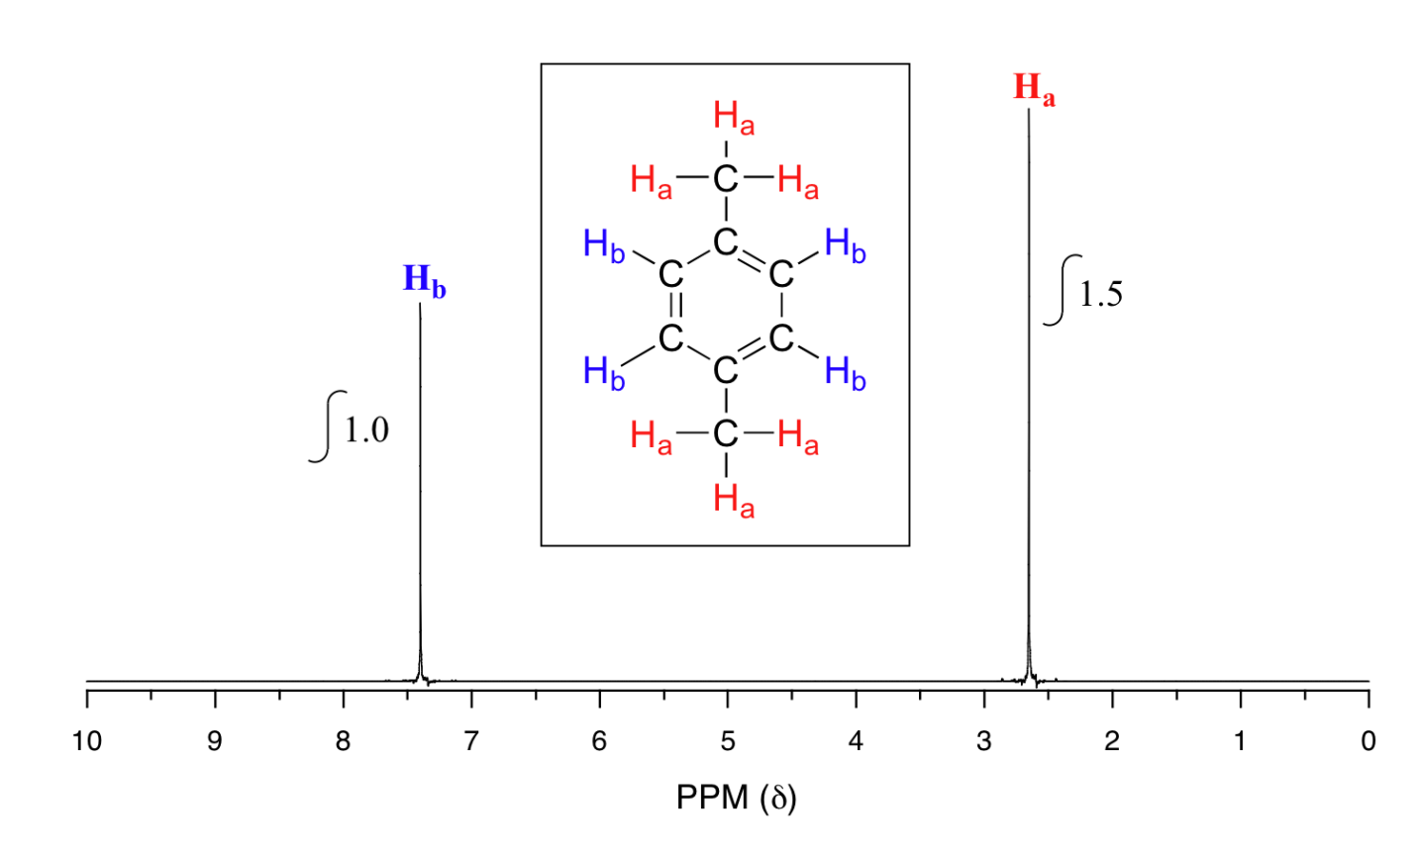
This molecule has two sets of protons: the six methyl (H_{a}) protons and the four aromatic (H_{b}) protons. When we instruct the instrument to integrate the areas under the two signals, we find that the area under the peak at 2.6 ppm is 1.5 times greater than the area under the peak at 7.4 ppm. This (along with the actual chemical shift values, which we'll discuss soon) tells us which set of protons corresponds to which NMR signal.
The integration function can also be used to determine the relative amounts of two or more compounds in a mixed sample. If we have a sample that is a 50:50 (mole/mole) mixture of benzene and acetone, for example, the acetone signal should integrate to the same value as the benzene sample, because both signals represent six equivalent protons. If we have a 50:50 mixture of acetone and cyclopentane, on the other hand, the ratio of the acetone peak area to the cylopentane peak area will be 3:5 (or 6:10), because the cyclopentane signal represents ten protons.
Example 1
You take a ¹H-NMR spectrum of a mixed sample of acetone (CH₃(CO)CH₃) and dichloromethane (CH₂Cl₂). The integral ratio of the two signals (acetone : dichloromethane) is 2.3 to 1. What is the molar ratio of the two compounds in the sample?
Example 2
You take the ¹H-NMR spectrum of a mixed sample of 36% para-xylene and 64% acetone in CDCl₃ solvent (structures are shown earlier in this chapter). How many peaks do you expect to see? What is the expected ratio of integration values for these peaks? (set the acetone peak integration equal to 1.0)
Solutions

Exercise

Questions
Q1
Predict how many signals the following molecule would have? Sketch the spectra and estimate the integration of the peaks.
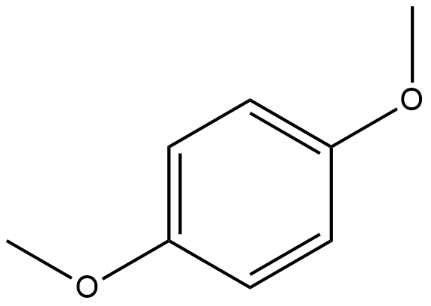

Solutions
S1
There will be two peaks. Ideal general spectrum shown with integration.
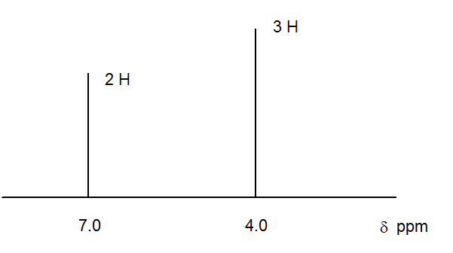

Splitting of the Signals:
The structure of a molecule can be predicted using NMR spectroscopy. However, the interpretation of the signals in an NMR spectrum relies on several factors. One of the factors affecting the location of the peaks in an NMR spectrum is Chemical shift. The location of the peaks is important in discovering how many protons there are in a molecule, as well as other information about the surrounding electronic environment. In addition to knowing where the peaks are, on the chemical shift scale, and what influences the delta value, one must also consider the fact that the peaks in an NMR spectrum are not always a singlet. In fact, the interactions between different types of protons present in the molecule cause a single peak on an NMR spectrum to split into doublet, triplet, or multiplet, a phenomenon known as the spin-spin coupling. There could also be other complex peak splitting patterns. The spin-spin coupling phenomenon, at its core, involves spinning nuclei.

The nuclear magnetic spin
A nucleus that has an odd number of protons spins along its axis. A proton has two possible spin states +1/2 or -1/2. In the absence of a magnetic field, these spins are quite random. In the presence of an external magnetic field, there is a tendency of the nuclei to align either with or against the magnetic field. The spins which are aligned with the external magnetic field have a lower energy state than the ones aligned against the magnetic field. The spin states and the energy levels are shown in the diagram below:
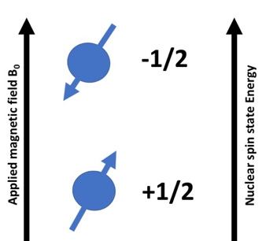
Depending on the orientation of the spins, the effective magnetic field on the proton would either increase or decrease by a small factor.
The applied magnetic field is denoted by Bo
The induced magnetic field is denoted by Bi
The effective magnetic field experienced by the proton
B_{eff} = B₀– B_{i}
At the core of the molecule, these spinning nuclei ultimately give rise to the phenomenon of coupling in NMR spectrum.

Spin-spin coupling between spinning nuclei:
The interaction between the spin magnetic moments of the different sets of H atoms in the molecule under study, is known as spin-spin coupling. It is imperative that a minimum of 2 sets of protons are present in adjacent positions. The magnetic spins of these resonating nuclei interact with each other and affect each other’s precession frequencies. The effective magnetic field (B_{eff}) experienced by neighboring protons as a result of magnetic spins thereby affect the chemical shift values. In addition to the chemical shifts, the nature of the peaks in the NMR spectrum is also affected.

Peak splitting in NMR spectroscopy:
A closer analysis of an NMR spectrum reveals that each signal on the graph represents one kind of proton present in the molecule. It is commonly observed that this signal is not always a single peak but has multiple peaks. This multiplicity of the signal is a very important determinant for the structure of the molecule. This phenomenon by which the spins of resonating protons cause the peaks on NMR spectrum to multiply is known as peak splitting. The splitting of NMR signal gives precise information about the number of neighboring protons in a molecule. There is a formula to calculate the multiplicity of the peaks in the NMR spectrum.
2nI + 1
n= Number of neighboring protons
I= spin number of protons
Since I is always ½, we can rewrite the formula as n+1.
The other relevant information which comes along with knowing the number of peaks is the intensity of the peaks (which is seen as the height of the peaks). As a general rule, the height of the peaks or in other words, the relative intensities of the peaks can be determined by using Pascal’s triangle.

Pascal’s triangle:
This is a number pattern invented by a famous French mathematician, Blaise Pascal. We can use the n+1 rule to determine the number of peaks. The height of the peaks, caused due to spin-spin coupling is in proportion to the values in the row (corresponding to the value n) in Pascal’s triangle. If we look at the figure below and consider a quartet, we would observe that the peak of the extreme signals is 1/3 of the first and the last peak.
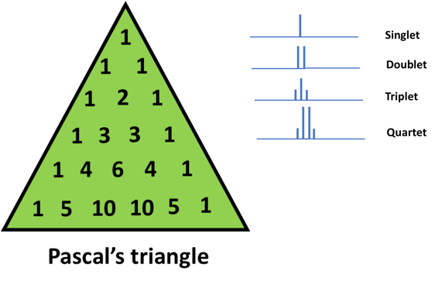
With n=0 (or 0 neighboring protons), we get a single peak. This is depicted as 1 at the apex of the Pascal’s triangle
Similarly, for n=1 (or 1 neighboring proton), we get a doublet (using the n+1 rule). This is written as 1 on either side of the second row in the Pascal’s triangle
Moving on, for n=2 (or 2 neighboring protons), we get a triplet. In this case, the number 1 is written at the left and right of the triangle and the sum (1+1) is shown in the middle.
For n=3, we get a quartet. In this case, again 1 is written at the ends and the neighboring numbers are added. Therefore, we end up with the sequence 1 3 3 1
We can explain the rest of the Pascal’s triangle in a similar way. This method of generating numbers is known as binomial expansion.
Let us try to understand peak splitting using the following molecule as an example;
CH₃CH₂Cl (Ethyl chloride)
Let us calculate the multiplicity for the hydrogen atoms.
There are 2 sets of hydrogen atoms in Ethyl Chloride and we should expect to get 2 peaks in the NMR spectrum. This, however, is not true when it comes to visualizing the actual spectrum. Each of the hydrogen atoms will influence the neighbors in an applied magnetic field and would lead to multiple peaks. To determine how many peaks we can get for hydrogen atoms in CH₂ or CH_{3,} we need to apply the above rule of multiplicity determination.
Let us look at the hydrogen atoms in CH₂ which are under the influence of 3 hydrogen atoms of the CH₃ group. Therefore,
n=3
I=1/2
After applying the formula,
2nI+1 = (2x3x1/2) + 1= 4
Therefore, there will be 4 peaks for hydrogen atoms in CH₂
Similarly, there would be 3 peaks for hydrogen atoms in CH₃
The position of the split peaks on the chemical shift scale (also known as the delta value) would be further influenced by the presence of the electronegative atom (chloride) in close proximity to hydrogen atoms in CH₂ .

Factors influencing peak split in NMR spectrum due to spin-spin coupling
We have seen earlier that the nuclei have a property known as spin. The spinning hydrogen nuclei in a molecule will interact with each other and cause the signal in the NMR peak to split. The separation distance between two adjacent peaks, as a result of the spin-spin interaction in a multiplet, is constant and is known as coupling constant (denoted by the letter J).
The value of the coupling constant depends on the following factors:
- Distance between the protons
The distance between the hydrogen atoms in a molecule is an important determinant in the value of J constant. If the hydrogen atoms involved in the coupling are closer to each other, these give rise to a greater value of J constant than if these atoms are further apart.
- The orientation of the coupled protons
The orientation or angle of the protons with respect to each other is equally important. The value of J constant is greater in molecules, where the H atoms are in the cis conformation. Conversely, it is less when the H atoms are in the trans conformation.

A curious case of singlets and doublets
Let us look at the interesting case of determining if the two adjacent peaks are doublets or actually made up of 2 singlets.
If we, for example, observe peaks in the molecule which are exactly 10 Hz apart and look indistinguishable from each other, it is very hard to decide if they are singlets or doublet.
Singlet/Doublet?

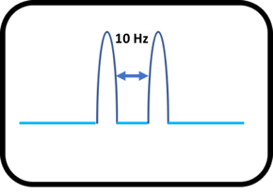

In order to know whether the peaks are a doublet, we would increase the applied magnetic field. Now, because the coupling constant (J) is constant between the adjacent peaks, the doublet peaks would be unaffected by the change of magnetic field. On the other hand, if the peaks were made of two singlets, then, the individual peaks would shift further apart on the chemical shift scale as shown below:

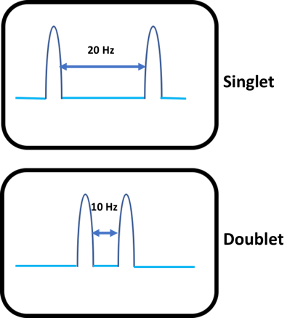

In the above example, if the peaks are doublets then the value of the coupling constant remains 10 Hz.
Unit of Coupling constant
The unit of a coupling constant is Hz and it is also referred as Cycles per second (CPS). The value of the coupling constant could be either positive or negative. The value of the coupling constant is a measure of interaction between neighboring protons. When two spinning nuclei are in the opposite orientation then the energy is lower and the value of the constant is positive. However, if the spinning nuclei are in the same orientation, then, the energy is higher and the value of the constant is negative. The spacing between the split lines or the J constant between coupling protons is of the same magnitude. The J constant can be used for distinguishing, e.g., between two singlets and one doublet or two doublet and one quartet. There is no effect of the external magnetic field on the coupling constant.

Different types of couplings and their effects on the coupling constant:
Geminal coupling: The term Geminal means that 2 atoms or functional groups are bound to the same carbon atom. The geminal or 2-bond coupling constant is denoted by ²J. This also denotes that there are 2 bonds between the hydrogens being coupled. In some cases, two hydrogen atoms can be attached to the same carbon atom but can be in a completely different electronic environment which give rise to different chemical shifts. These protons are known as Geminal protons. Let us look at the molecule below:
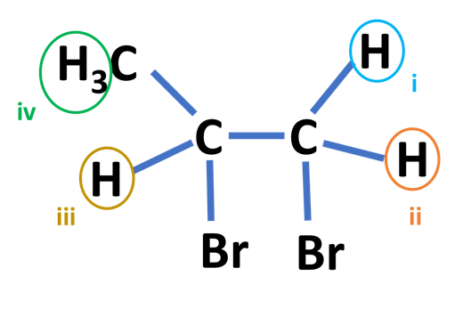
According to the definition of Geminal protons, the protons i and ii are geminal protons, as they are attached to the same carbon atom, however, their electronic environments are sdifferent. The coupling constant value will also depend on the angle between protons i and ii. The coupling constant will increase with the electronegativity of the groups.
Vicinal Coupling: Vicinal protons are those which are separated by three bonds. In the molecule shown above, ii and iii are vicinal protons. The vicinal or 3 bond coupling constants is denoted by ³J. The hydrogen atoms are on the adjacent carbon atoms in vicinal coupling.
Long range coupling: If the distance between two protons is more than 3 covalent bonds, then, the phenomenon of coupling does not come into play. However, there would be some coupling if there are unsaturated or fluoro compounds present in the vicinity of the protons. Such type of coupling can only be observed using a very sensitive and high-resolution NMR spectrophotometer (e.g. the 600 MHz Bruker Avance Spectrometer).

Complex splitting patterns on NMR spectrum
The NMR spectrum can sometimes have more complex splitting patterns than the simpler couplings involving equivalent coupling constants (such as doublet, triplet, quartet, quintet etc.). It may sometimes happen that each peak in a doublet (in an NMR spectrum) is further split into another peak. Such cases happen when a hydrogen atom is influenced by 2 adjacent non-equivalent hydrogen atoms. These complex patterns manifest as doublet of doublets, doublet of triplets, triplet of doublets etc.

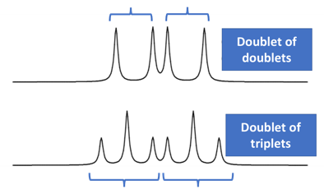

Let us investigate this effect using a molecule named methyl acrylate
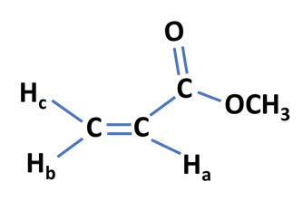
The protons H_{a} and H_{b} are coupled and would give rise to a doublet. The proton H_{c} is a non-equivalent proton and this would give rise to further splitting into a doublet of doublets. It is important to note that H_{c} is coupled to both H_{a} and H_{b} but having different coupling constants. This is why each line in the doublet would further split into another doublet.

Nuclear Overhauser Effect (N.O. E.):
The nuclear Overhauser effect (NOE) is the transfer of nuclear spin polarization from one population of spin-active nuclei (e.g. ¹H, ¹³C, ¹⁵N etc.) to another via cross-relaxation. A phenomenological definition of the NOE in nuclear magnetic resonance spectroscopy (NMR) is the change in the integrated intensity (positive or negative) of one NMR resonance that occurs when another is saturated by irradiation with an RF field. The change in resonance intensity of a nucleus is a consequence of the nucleus being close in space to those directly affected by the RF perturbation.
The NOE is particularly important in the assignment of NMR resonances, and the elucidation and confirmation of the structures or configurations of organic and biological molecules. The two-dimensional NOE experiment (NOESY) is an important tool to identify stereochemistry of proteins and other biomolecules in solution, whereas in solid form crystal x-ray diffraction must be used to identify the stereochemistry.
While the relationship of the steady-state NOE to internuclear distance is complex, depending on relaxation rates and molecular motion, in many instances for small rapidly tumbling molecules in the extreme-narrowing limit, the semiquantitative nature of positive NOE's is useful for many structural applications often in combination with the measurement of J-coupling constants. For example, NOE enhancements can be used to confirm NMR resonance assignments, distinguish between structural isomers, identify aromatic ring substitution patterns and aliphatic substituent configurations, and determine conformational preferences

