E-Content
B.Sc. 2nd Year
Inorganic Chemistry Paper-I
UNIT-I
Chapter 2
PART-II

CHEMISTRY OF THE ELEMENTS OF SECOND ANDTHIRD TRANSITION SERIES

Dr. Anil Kumar
Associate Professor,
Department of Chemistry,
Harish Chandra P G College,
Maidagin Varanasi, UP-221001
e-mail:anilk642@gmail.com

Stereochemistry of 4d and 5d series
The geometry of the complex compound of second and third transition series of Zr/Hf, Nb/Ta, Mo/W have already been discussed. According to the coordination number the geometry can be predicted of their complexes compound by any ions in transition elements the most common coordination number is six resulting in octahedral geometry. For four coordinated complexes, tetrahedral or square planar geometry are found. The coordination number 7 and 8 are uncommon in first transition series elements, but in these two second and third transition series i.e.4d and 5d are too common. In the table given below examples of 7 and 8 coordination of these series are summarized.
Example Coordination Number Geometry

[Zr (CO)₅ (Sn Me₃ )₂ ]²⁻ 7 pentagonal bipyramidal
[Zr (C₂ O₄ )_{2]} ⁴⁻ 8 square antiprism
[ Na Hf F₇] 7 pentagonal bipyramidal
Elements | Symbol | Atomic  No. | Atomic &Ionic  Radii(A⁰)  (+4state) | Electro-  nega-  tivity | M.P. | B.P. | density | Electronic configuration
Titanium  Zirconium  Hafnium | Ti  Zr  Hf | 22  40  72 | 1.32  (0.59)  1.45  (0.79)  1.49  (0.80) | 1.5  1.4  1.3 | 1726  1760  2200 | 3260  3580  5400 | 4.56  6.51  13.28 | [Ar]3d² 4s²  [Kr]4d² 5s²  [Xe]4f¹⁴5d³ 6s²
[K₃ Nb F_{7]} 7 distorted pentagonal bipyramidal
[Ta (N Me₂) (S₂ CH Me₂ )₃] 7 distorted pentagonal bipyramidal
[Mo (CN )₈ ]⁴⁻ 8 Decahedral
[ W (CN )₈ ]⁴⁻ 8 Decahedral

Comparative study of the second and third transition elements:
Zirconium and hafnium(Zr/Hf)
Group IV-B(4) consist the elements titanium zirconium, hafnium. Their physical properties are given in following table:

Both zirconium and hafnium have high +4 oxidation states. Further these elements have larger atomic and ionic radii compared to titanium, though both the elements have identical radii this is because of presence of f-orbital and due to lanthanide contraction in Hf. Thus, the two elements have also similar chemistry and form the binary tetra halides. Tetra halides are monomer in gaseous state but showed octahedral coordination in the solid state.
The tetra halides compounds are readily hydrolysed to give ZrX₂ and HfOX₂. The compound ZrCl₄.8H₂O further crystallises from dil. HCl as [Zr₄(OH)₈(H2O)₆] ⁶⁺ have been established by X-ray crystallography. The 7 and 8 coordination with oxygen (O) and fluorine (F) ligands; For example, Na₃ZrF₇, trigonal prism and square antiprism geometry respectively.
Other eight coordinated complexes for zirconium are Zr(O₂CR)₄, Zr(acac)₄, Na_{4 [}Zr(oxalate)_{4]} and [Zr (NO₃)_{4]}.
The established (III) oxidation state compounds of Zirconium and Hafnium are ZrCl₃, ZrB3, ZrI₃ and HfCl₃ and HfBr₃ respectively.
Niobium and tantalum (Nb/Ta)
Group V-B (5) contains the elements vanadium, niobium, tantalum. Their physical properties are given in the following table.
Elements | Symbol | Atomic  No. | Atomic & Ionic  Radii(A⁰) (+4) | Electro-  nega-  tivity | M.P. | B.P. | density | Electronic configuration
Vanadium  Niobium  Tantalum | V  Nb  Ta | 23  41  73 | 1.22  (0.64)  1.34  (0.72  1.34  (0.72) | 1.6  1.6  1.5 | 1915  2468  2980 | 3350  4258  5534 | 6.11  8.57  16.65 | [Ar]3d³ 4s²  [Kr]4d⁴ 5s¹  [Xe]4f¹⁴5d³ 6s²
The two metals are generally present together in their ore. They are separated by fractional crystallization of KTaF₂ and K₂NbO₂ in presence of KHF₂/HF. After separation these metals obtained in pure form by electrolysis and aluminothermic process.
Their atomic and ionic radius are almost equal but larger than 3d series group elements again this is because of presence of f-orbital and due to lanthanide contraction in Ta. Both are steel grey colour metal and resist the attacks of many chemical reagents.
Owing to their oxidation state, most of their compounds are trivalent compounds and show tendency to form oxy compounds. This is the reason why they do not form cationic complexes like other 3d metals. The coordination number of these anionic complexes is generally seven and eight.
Tantalum and Niobium form pentavalent compounds M₂O₅ those are white amorphous powder but if heated to red hot it becomes incandescent and possess into crystalline state.
Halides and oxyhalides of niobium and tantalum exist in their higher oxidation state and are obtained by action of pentoxide with CCl₄ at higher temperature by the following reaction.

CCl4 Hf
M₂O₅ M₂Cl₁₀ (MF₅)₄
₃₀₀⁰_{c}

The structure of tetrameric compounds is given as:
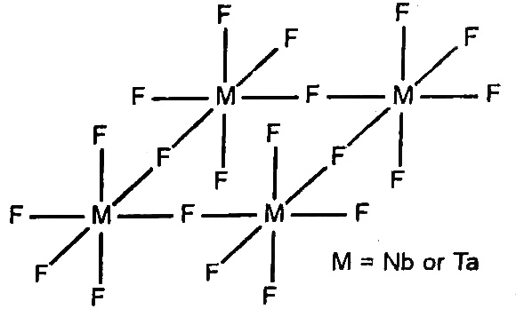
Fig. Tetrameric Structure of Nb and Ta in Pentameric Fluoride (MF₅)
Niobium pentachloride NbCl₅ is a yellow crystalline solid and dissolved in many organic solvents, directly prepared by action of niobium metal and chlorine.
4Nb + 5Cl₂ 2Nb₂Cl₅
Nb₂Cl₂ is a dimer and stabilises in octahedron geometry as:

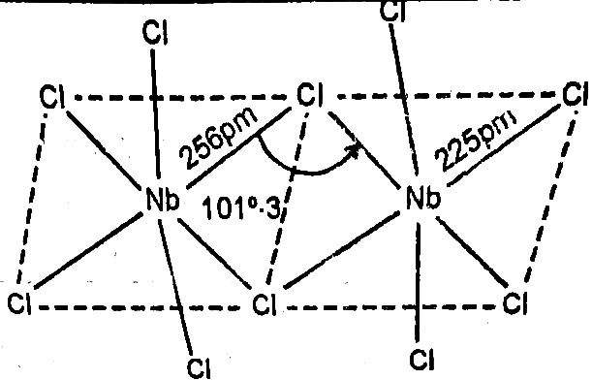 Fig. 2.2Dimeric structure of (NbCl₅)
It is hydrolysed by water forming oxy halides of the composition (Mo X₃) [M = Nb and Ta]. These compounds are generally polymeric and covalent in nature. Halides of Nb and Ta of lower oxidation state (trivalent and divalent) forms cluster compounds by heating the pentahalides with metal. These compounds are in an octahedral M₆ unit containing the basic unit [M₆X₁₂]. Metal are octahedrally held together by M-M bond over metal atom along with additional halogens atom bridged along the twelve edges of octahedron.

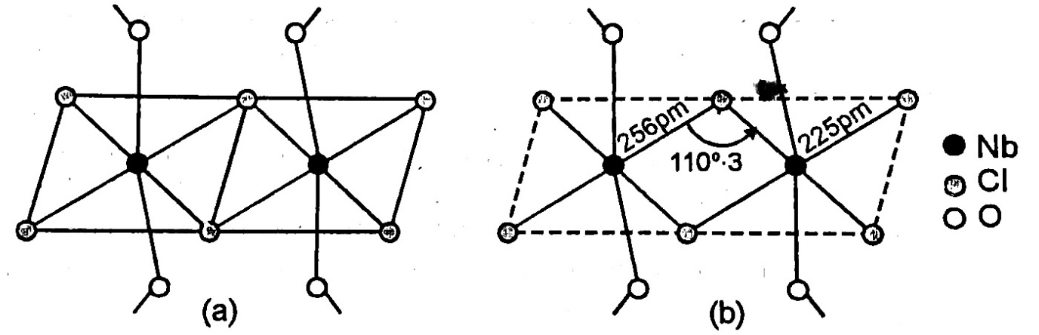
Fig. The structure of (a) NbOCl₃ and (b) NbCl₃

Tungsten and molybdenum (W/Mo)
This group consist of elements chromium, molybdenum and tungsten. Different oxidation states are responsible for paramagnetic behaviour and complex formations are also the common features like other 3d elements. Some of the important properties of these elements are given below:
Elements | Symbol | Atomic  No. | Ionic  Radii(A⁰)  (+4state) | Electro-  nega-  tivity | M.P. | B.P. | density | Electronic configuration
Chromium  Molybdenum  Tungsten | Cr  Mo  W | 24  42  74 | 0.58  0.73  0.74 | 1.6  1.8  1.7 | 1875  2610  3410 | 2199  5560  5900 | 7.1  10.4  19.3 | [Ar]3d⁵ 4s¹  [Kr]4d⁵ 5s¹  [Xe]4f¹⁴5d⁴ 6s²

Chromium stabilizes in +3 oxidation state while molybdenum and tungsten are unstable in this valency state. All the elements in this group exhibited maximum oxidation number +6 . The valency six is the highest valency for all the elements in this group. The chromium has +3 oxidation state, is more stable state while +6 oxidation state is more oxidizing. Whereas, Mo(III) and W(III) are strong reducing in nature. Molybdenum and Tungsten have similar atomic and ionic radii this is because of presence of f-orbital and due to lanthanide contraction in W but atomic number of tungsten almost double that of Mo. Mo and tungsten possess similar chemical properties.

Halides of Mo and W
Molybdenum reacts with chlorine forms dark reddish dimeric Penta chloride solid, Mo₂ClO while fluorine gives MoF₆ and WF₆.
Mo + 2Cl₂ MoCl₄
W + 3Cl₂ WCl₆
Mo + 3F₂ MoF₆
At high temperature molybdenum forms several chlorine compounds at different conditions.
Mo + Cl₂ Mo₂ Cl₁₀MoCl₄
_{MoCl3MoO2}
MoCl₄ Mo₆Cl₁₂ [MoCl₈]⁴⁺ (solid)
Molybdenum and tungsten in their lower oxidation state stabilise by meta-metal interaction and forms MoCl₃ and W₂Cl₄ compounds.

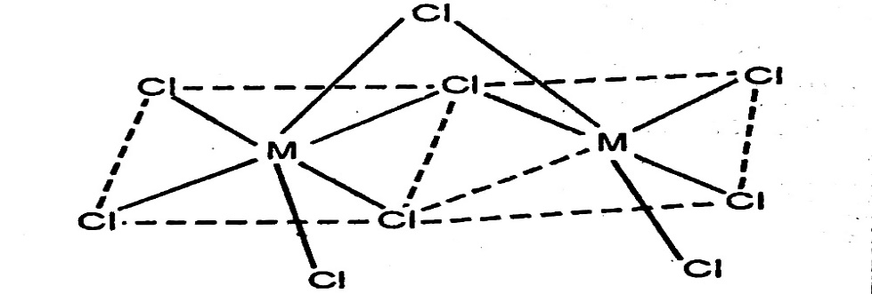
Fig [M₂Cl₉]³⁻ (M=Mo and W)
The structural characterization on the basis of low magnetic moment and bond distance between the metals, further supported the dimeric structure.
Molybdenum reacts with HCl in presence of KCl yield the anionic compounds [Mo₂Cl₈]₄.

EXERCISE

Long Answer Type Questions:
1. Describe the general characteristics of 4d and 5d series elements on the following lines:
(i) Electronic configuration
(ii) Atomic and Ionic Radii
(iii) magnetic behaviour
2. “The elements of second and third transition series resemble each other more closely than they resemble the element of first transition series”. Explain this fact with reference to their atomic radii, oxidation states, magnetic behaviour and complex formation tendency.
(VSBP University, Jaunpur 2006)
3. Describe the general characteristics of the elements of second and third transition series. In what respect these elements differ from 3d series elements? (VBSP University 2007)
4. How do Zr and Hf show similarities with each other? How are they separated from each other? in a pure state? (MGKV University 2012)
5. Give a comparative account of the general chemistry of Cr, Mo and W. Also discuss the position of these elements in the periodic tables. (MGKV University 2012)
6. Give the electronic configuration of 4d and 5d transition elements. Comment on their size, oxidation states and magnetic properties. (MGKV University 2013)
7. Describe the general characteristics of second and third transition series with special reference to oxidation states and magnetic properties. (MGKV University 2014)
8. Discuss d-block element. Explain the characteristics of I and II d block elements with reference to their ionic radii, magnetic behaviour and complex formation. (MGKV-2016)
9. Explain the following characteristics of transition elements with reference to Zr/Hf.
(i) Ionic radii (ii) oxidation state (iii) magnetic properties (iv) spectral properties
(MGKV University 2017)
10. Discuss the general characteristics of transition elements of 4d and 5d series elements. (Kanpur 2011)
11. Compare the properties of elements of 3d transition series with those of 4d and 5d transition series. (Agra-2009)
12. Give reason:
(i) Why do Zr and Hf display similar properties?
(ii) There is no much difference of atomic size from Cr to Cu.
(iii) First IP of 5d elements are higher than 3d and 5d series elements.
(iv) Why the salt of Zn, Cd and Hg are generally white. (VBSP University jaunpur)
13. Explain with reason:
(i) size of Zr and Hf is almost same
(ii) Hg is liquid at normal temperature.
(iii) Most of d-block elements show catalytic properties.
(iv) Atomic radius of Hf is nearly equal to Zr.
14. Give the answer of following.
(a) Discuss the names and electronic configuration of 4d and 5d series elements.
(b) Explain why the 1st IP of hg is higher than that of Cd.
(c) Compare the general behaviour of oxidation states of the 2nd and 3rd transition elements.
15. Discuss comparative treatment of Zr/Hf, Nb/Ta and Mo/W in respect of ionic radii,oxidation state, magnetic properties, spectral properties and stereochemistry.
Short Answer Type Questions:
1. How magnetic moment of second and third transition series elements is evaluated?
2. Give the comparative treatment of Zr/Hf in respect of spectral properties and
stereochemistry.
3. Write the comparative treatment of Mo/W in respect of ionic radii, oxidation state and magnetic properties.
4. Discuss the comparative treatment of Nb/Ta with respect to spectral properties and Stereochemistry.
5. Why do Zr/Hf, Nb/Ta and Mo/W display similar properties?
6. Why Mo/W show similar atomic and ionic radii value?
7. Why atomic and ionic radii value of 5d series transition elements is lower than 4d series elements?
8. Why Coinage metals show variable valency?
9. Compare the properties of Cr, Mo and W.
10. Why Hg and Cd complexes are colourless?
11. Discuss the mechanism of complex compound of Platinum used in the treatment of Cancer?
12. 4d and 5d transition metal highly resemble with each other, why?
13. Zr/Hf and Mo/W occur in the form of pair. Explain. (Lucknow 2010)
14. Discuss the similarities found in between elements, ions, Ruthenium and Osmium.
15. Explain why Pt(IV) complexes are generally octahedral while Pt(II) complexes are square planar. (Meerut 1983)
Multiple Choice Questions:
1. Among the following group of elements the group containing only 4d series elements are:
(a) Cr, W, Cu (b) W, Au, Hg (c) W, Mo, Cr (d) Ru, Rh, Ag
2. The member of 5d series transition elements are:
(a) W, Cr, Y (b) Hf, Ta, Au (c) Y, Hg, Cd (d) W, Os, Cu
3. Gold is attacked by
(a) Conc. HNO₃ (b) Conc. HCl (c) Conc. H₂SO₄ (d) aqua regia
4. Nessler’s reagent is a-
(a) Solution of mercuric iodide in potassium iodide
(b) Solution of mercurous iodide in KI
(c) Solution of mercuric chloride in KI
(d) Solution of mercuric chloride in KBr
5. Monel metal is alloy of
(a) Cu & Ni (b) Cu, Ni & Zn (c) Cu, Ni & Cr (d) Ni & Cr
6. Among the transition metal highest +8 Oxidation state is displayed by
(a) Os & Mo (b) Os & Ru (c) Ru & Rd (d) Ni & Cr
7. The non-typical transition elements are
(a) Sc, Y, V, Cr (b) Y, La, Ti, V (c) Sc, Y, La, Ac (d) Sc, Zr, Y, Hf
8. Atomic Number of last elements of 3rd transition series is
(a) 57 (b) 67 (c) 66 (d) 80
9. Lanthanum belongs to which transition series?
(a) 3d (b) 4d (c) 5d (d) none of these
10. How many elements are present in 5d series elements
(a) 20 (b) 10 (c) 5 (d) 15
11. The geometry of [Mo(CN)₈]³⁻ complex ion is
(a) Cube (b) pentagonal bipyramid (c) capped octahedron (d) square pyramid
12. in the complex ion [ReH₉]²⁻ coordination no. is
(a) CN=3 (b) CN=6 (c) CN=7 (d) CN=9
13. Valence shell electronic configuration of Niobium (Nb) is
(a) 4d³ 5s² (b) 5d⁴ 6s² (c) 3d² 4s² (d) None of these
14. Hg²⁺, Au⁺& Ag⁺ ions are
(a) paramagnetic (b) ferromagnetic (c) diamagnetic (d) none of these
15. The atomic radii value of 4d & 5d series transition elements are nearly same because of-
(a) atomic no is same (b) Lanthanide contraction
(c) shielding effect (d) None of these

Answers
1- (d), 2-(b), 3-(d), 4-(a), 5-(a), 6-(b), 7-(c), 8-(d), 9-(c), 10-(b), 11-(a), 12-(d), 13-(a), 14-(c), 15-(b)

